Models and Activity Diagrams

Context Model

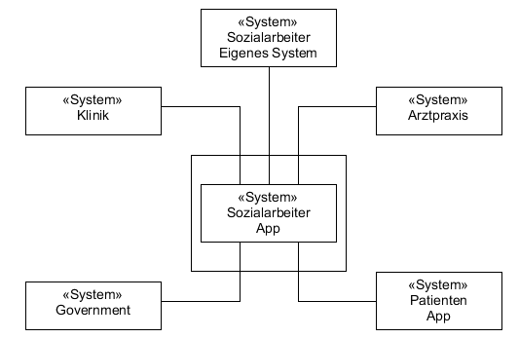

Activity Diagram System Government

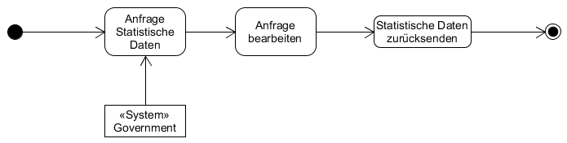

Activity Diagram System Sozialarbeiter (own system)

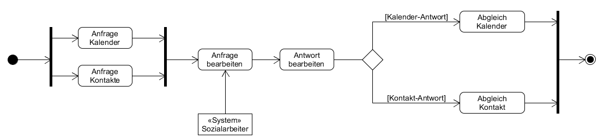

Activity Diagram System Klinik

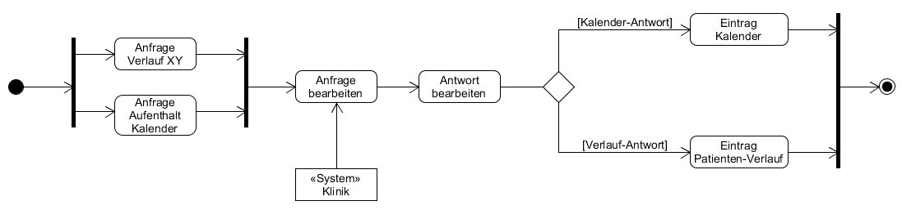

Activity Diagram System Arztpraxis

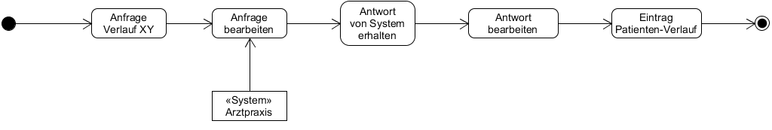

Activity Diagram System Patienten-App

